2020 Shorewood Junior Golf Program

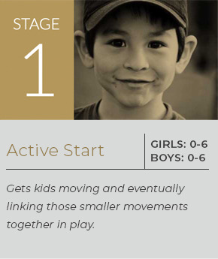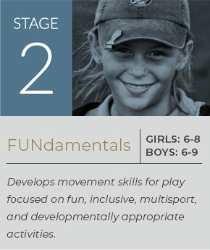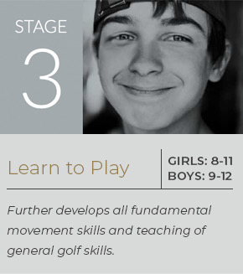

An American Development Model and PGA Coach Program

Welcome to the 2020 Shorewood Country Club Junior Golf Program and Academy. As you read through this information I wanted to highlight changes and improvements as we head into a new era in Junior Golf. First, a word about Covid-19. Everything and anything we do in this program, as well as every area of Shorewood Country Club, is about health and safety. The program will again offer 8 Lessons and 8 Play Days. We will practice physical distancing, have small group instruction, utilize tee times, have a student-teacher ratio of 10-1, more streamlined play days, more team oriented play days and, with your help, support and participation, we will have a widely renowned Junior Golf Program.

Some of the changes in the program are as follows:
- PGA of America American Development Model and PGA Coach Program
- Lower Entry Fees: Each classification of Junior Participant—(Member, Social Member, and Public) will realize an average reduction of fees of $36.50 per participant.
- Scheduled Tee Times Each Play Day with emphasis on team participation each play day. All players must register before Noon the day before play day so as to create tee times. Players will play own golf ball but there will be a team event as well.
- Play will be from either yardage discs or tees, dependent on level.
- Play of the golf course will be in sequential order so as to accommodate as many players as possible.
- Parents may walk with their children on play days.
- Goal of play days is to increase skill, comradery, fun and enjoyment of playing.
- Student Teacher Ratio of 10-1: This will be accomplished by increasing instruction hours and each student will receive specified instruction times to insure ratio. Improvement leads to more fun and enjoyment.
- Lesson times will be utilized to maximize improvement. Skills, skill games, objectives and goals will be laid out for every lesson. Lesson plans provided at the beginning of each lesson.
- Assessments utilizing PGA Coach and the American Development Model will be part of instruction.
- Special program dates and times and fees will be developed for those children ages 5 and under.
- Tournament One: The Observer Open which will be a team event from all age/hole groups.
- Tournament Two: Bobby Steele Shorewood Country Club Junior Club Championship: Two days of individual play with competition conducted within divisions.
We are going to try to start the program earlier in the year in order to maximize enjoyment of the program. It is becoming apparent that Golf may very well be the only sport offered in the near future. If we must, we have a complete schedule for the program that will be used if we need to push the program further into 2020 due to Covid-19.
The program is open to both the Public AND Shorewood Members, and is available for kids ages 5 to 18. The program will consist of lessons, on-course instruction, practice time on the course, and tournament play. Junior golfers will be divided up into groups for both lesson and play purposes, these groups are based on prior experience and performance as well as the above American Development Model age divisions.

PRICE PER JUNIOR GOLFER

Shorewood Class A Member $80.00
DUE TO ANONYMOUS JUNIOR GOLF BENEFACTOR—THE FEE IN 2020 IS
$35.00/CHILD

Shorewood Class A1 Member $85.00
Shorewood Social Member $90.00

Public $99.00

Please complete the enclosed Registration Form and information.. Please bring each form, along with check or cash, to registration. Please make checks payable to Shorewood Country Club. If you are a member of Shorewood in good standing you may bill your account for the registration fee.

Please contact Rich Conwell, PGA Head Golf Professional, at 716-366-1880 ext. 5 with any questions about the Junior Golf Program.

Enclosed with this registration form is a junior golf schedule complete with lesson dates,, tournament dates and other pertinent information. Shorewood Country Club is committed to providing an excellent Junior Golf Program complete with instruction, competition and fun so that the game of golf can be enjoyed for a lifetime. Thank you for your participation.
Shorewood Junior Golf 2020
Registration Form

Parent’s Names________________________________Member Public

Mailing Address________________________________________Phone___________________

**E-Mail Address**_____________________________________________________________

**Please Note that we will notify you via email for all cancellations of lessons and/or tournament play**

In Case of Emergency, Notify_____________________________________________________

Relationship to Golfer____________________________________Phone___________________

Children’s Information (as of April 1, 2020)

Name_________________________Date of Birth____________Age_________

Name_________________________Date of Birth____________Age_________

Name_________________________Date of Birth____________Age_________

Method of payment:

Cash Check Member Charge (Type and Number) __________

We agree to accept full responsibility for the welfare of our children while the participate in all the events related to the Shorewood Junior Golf Program, and we agree to waive liability against Shorewood Country Club and those directing and instructing the program.

Parent Signature_________________________________________
Shorewood Junior Golf Program

Code of Conduct

Parent/Guardian Name: ________________________________________

All junior golfers and their parents MUST read and sign this form in order to participate in the Shorewood Junior Golf Program.

1 – Proper attire will be worn at all times on the golf course, in the Grove, Pro Shop and Clubhouse. (No t-shirts, short shorts or jeans)

2 – Proper language will be used at all times on the golf course, in the Grove, Pro Shop and Clubhouse. (No swearing or abusive language)

3 – Proper etiquette will be displayed at all times on the golf course, in the Grove, Pro Shop and Clubhouse. (No throwing clubs, bags or other objects)

4 – Proper respect will be given to the Golf Professional, Jr. Golf committee and all Walkers. Questions about golf rules should be brought to the attention of the Golf Professional at the end of the golf round.

5 – Absolutely NO drinking alcohol, smoking, chewing tobacco or using illegal substances at any time.

Any golfer who does not abide by these rules will be required to leave the golf course immediately. Repeat offenders will be dismissed from the
Junior Golf Program.

Signatures below indicate I/we agree to abide by the Code of Conduct.

Junior Golf Participant(s):

___________________________________________________

___________________________________________________

Parent/Guardian:___________________________________________________

2020 Shorewood Country Club Junior Golf Program
Schedule and Program Times

**Please Note: Lesson Curriculum Will Be Tailored To Each Group**
May 23, 24 and 25 Registration Weekend and Registrations Open

Monday June 22 Welcome Night Cookout and Orientation

Tuesday June 23 Golf Lesson #1

Wednesday June 24 Golf Lesson #2

Tuesday June 30 Play Day Number One

Wednesday July 1 Golf Lesson #3

Monday July 6 Play Day Number Two

Wednesday July 8 Golf Lessson #4

Monday July 13 Play Day Number Three

Tuesday July 14 Golf Lesson #5

Wednesday July 15 Golf Lesson #6

Monday July 20 Observer Open—Play Day Number Four—Food Afterward

Monday July 27 Play Day Number Five

Wednesday July 29 Golf Lesson #7

Tuesday August 4 Play Day Number Six

Wednesday August 5 Golf Lesson #8

Monday & Tuesday Shorewood Country Club Bobby Steele Memorial
August 10 and 11 Junior Club Championship Rounds One and Two

August 11 Junior Golf Banquet

***TIMES FOR THE PLAY DAYS AND LESSONS WILL BE DETERMINED BASED ON TEE TIMES AND STUDENT-TEACHER RATIO. THESE WILL BE COMMUNICATED WELL IN ADVANCE OF EACH LESSON OR PLAY DAY.***

