SHOREWOOD COUNTRY CLUB
Application for
INTRODUCTORY Membership
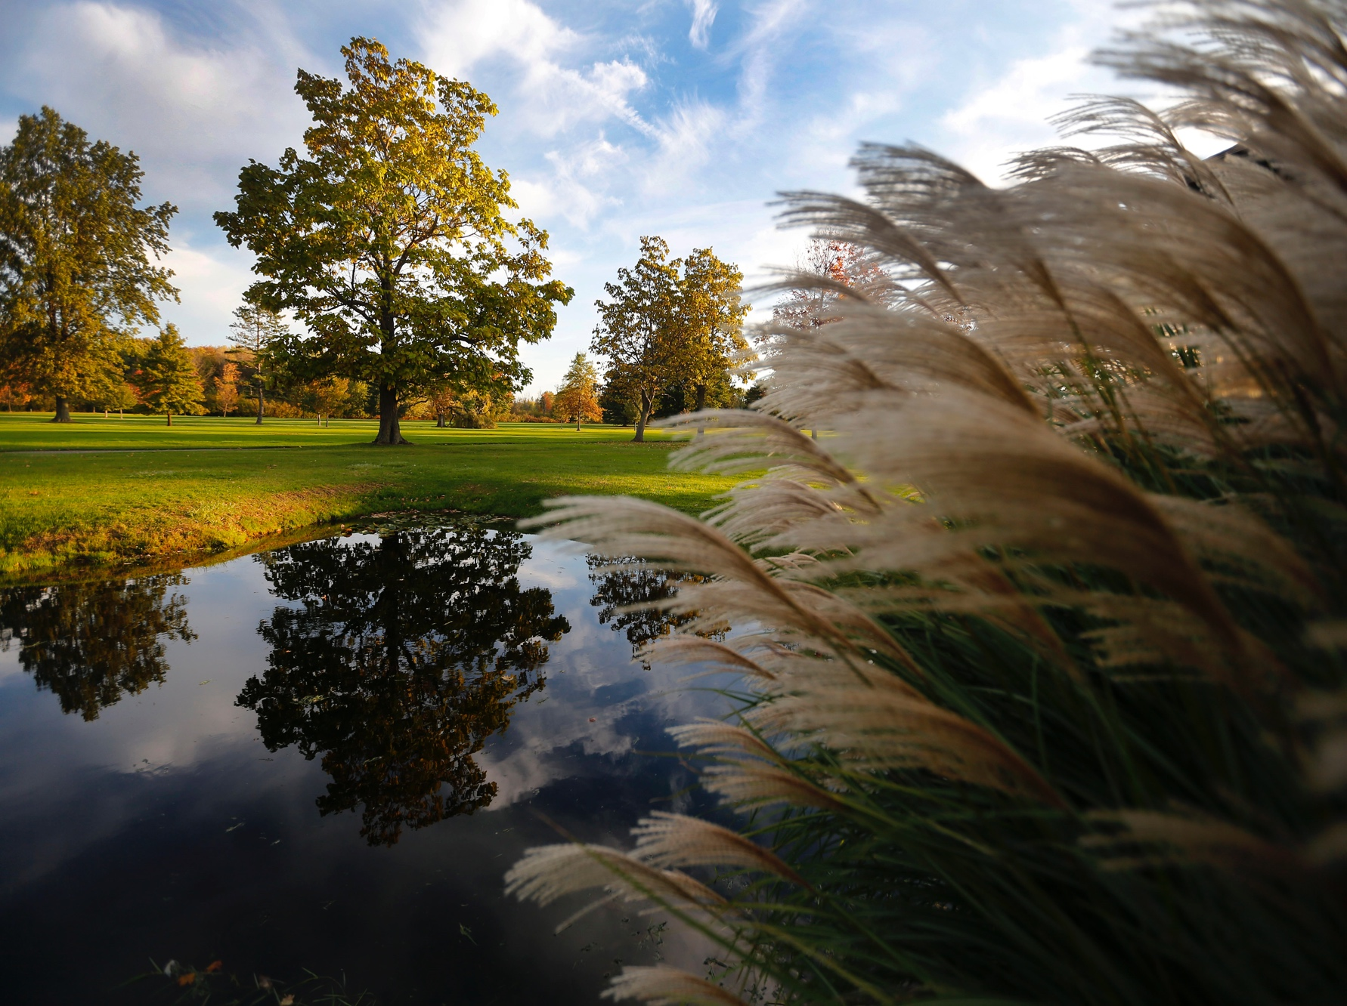

4958 WEST LAKE RD.
DUNKIRK, NY 14048
(716) 366-1880

FAX: (716) 366-0038
EMAIL: Swoyer@ShorewoodCC.com
www.ShorewoodCC.com

YOUR INVITED TO JOIN

2020 Introductory
Membership Fees

Full Golf Introductory Membership

Full golf membership includes use of our 18 hole championship golf course, practice area, clubhouse, lounge, outdoor patio, heated pool and lakeside fire pit. We have a full service pro shop and a PGA professional on staff to help you learn or improve your game. Enjoy lakeside casual and fine dining as well as social events that give members the opportunity to network, entertain clients and make life long friends. Full family memberships include 2 adults, dependents under 21or under 24 if in college or military service.

Full Social Membership

Full social membership includes the use of clubhouse, lakeside casual and fine dining, lounge, outdoor patio, heated pool, lakeside fire pit and the option to purchase and play 3 rounds of golf. We have several events throughout the year that give members the opportunity to network, entertain clients or just relax and have fun. Social memberships include 2 adults, dependents under 21or under 24 if in college or the military service.

Monthly No Assessments

Full Family Golf (A) $ 147.92 $ 0
Single Golf (A1) $ 116.25 $ 0

A1 Junior Golf* $81.25 $ 0
*(No Food & Beverage Minimums)
*(Ages 30 & Under)

Social Membership (B)* $22.75 $ 0

Monthly Food & Beverage Minimums $75.00

*Year 2 social membership continues to regular social member rate of $628 ($52.33 per month after first 12 months)
Please contact Tricia Laurito for more information. You can reach her at (716) -366-1880 ext 2 or at tricia@shorewoodcc.com.

GOLF MEMBERSHIP ENHANCEMENTS:

We have a number of extra services that we have available to our golfing memberships that we hope will add to your enjoyment of the game. You are not expected to purchase one or all of the following. If you wish to purchase one or more, please contact Tricia Laurito, our financial manager. Subject to NYS Sales tax.

Annual Cart Plan – If you wish to not pay-as-you-go all season, the cart plan is right for you. This offer is not refundable and cannot be prorated.
Single Cart Plan - $599.00 Family Cart Plan - $858.00

Golf Club Storage – Have your golf clubs cleaned and stored safely within our Pro Shop.
$50.00 per bag

Lockers – Available for men & women to rent in the clubhouse with nearby showers for your convenience.
$30.00 per locker

Hole in One Club – Any golfer in this club will be eligible for a hole in one money prize. ONLY WHEN a hole in one is hit, each member involved will be member charged a $5.00 fee that will be given to the member who hit the hole in one!
$5.00 each member that would like to participate

Men’s League – Open to all male golf members. Starts mid-May on Thursdays. A great night out with a great group of people. Proceeds for league go towards prizes and meals for opening and closing stags, etc.
$95.00 per person

Women’s League – Open to all female golf members. Starts mid-May on Wednesday nights. Proceeds for league go towards prizes and meals for opening dinner and end of the year banquet, etc.
$85.00 per person
(SWGA Fee of $20.00 will be charged in April if you golf in Women’s League)

Junior Golf- Our popular junior golf program includes weekly lessons and use of our heated pool. Our golf professional Rich Conwell makes this program fun and interesting for kids.

SWA Fee – A $10.00 annual charge to benefit the Women’s Association. The Shorewood Women’s Association plans many fun activities throughout the year. They are always a looking for new members to join. May opt out.

Please contact Tricia Laurito if you are interested in any of these optional items or if you have any questions. You can reach her at (716) -366-1880 ext 2 or at tricia@shorewoodcc.com.

Application for Membership

Name in Full: _________________________ Birth Date: ____________
Name of Spouse: ______________________ Birth Date: ____________
Residence Address: ____________________ City: ________________ State: _____ Zip: _________
Cell Number: _______________________ Spouse Cell Number: ___________________
Email Address: ________________________ Spouse Email Address: ____________________
Employer: ___________________________ Title: __________________________________

Full Name & Birth Date of Each Child under 18 years old:

- ___________________________ 3. ______________________________

- ___________________________ 4. ______________________________

Class of Membership:

Full Intro Golf – A Membership (ages 31-64): ____ (Family) ____(Single)

Junior Intro Golf – A Jr. Membership (ages 18-30): ____ (Family) ____(Single)

Senior Golfer – E Membership (over age 65): ____ (Family) ____(Single)

Non-Resident Intro Golf – C Membership (ages 36-64): ____ (Family) ____(Single)

Social Membership (all ages) ____ (ages 18-35) ____ (ages 36+)

How did you hear about Shorewood Country Club? ________________________________________________

Is there anyone that you know who may be interested in joining our club? Please provide contact information.
_____________________________________________________

Annual or Monthly Billing:_________________________________________
Member Sponsor (if applicable):____________________________________

I, __________________________________________ , hereby apply for a membership in Shorewood Association Inc., d/b/a Shorewood Country Club located at 4958 West Lake Rd. Dunkirk, New York, 14048 and hereby referred to as Shorewood Country Club.
Upon acceptance of my application for membership, I agree to comply with all terms and conditions (copy attached) governing my membership. I also understand that this application becomes a membership contract for twelve calendar months.

Signature: __________________________________ Date of Application: ________________

Terms and Conditions

Upon approval by the Board of Directors, any person
electing to join Shorewood country club shall
do so knowing that:

A 12 month financial commitment is required.

Introductory rate memberships carry non-voting status.

Former golf members must be 3 years removed for eligibility and have not
utilized the Introductory Rate before.

All new social applications are welcome.

Members are subject to the Constitution and By-Laws as well as all rules of
Shorewood that now exist or that may be adopted in the future.

All monthly charges including dues, food and beverage minimums, and fees
must be paid in full for each billing cycle.

Accounts are considered delinquent 30 days from the statement
date and are subject to a finance charge of 1.5% monthly.

